**Name__________________________________ Similar Triangles**

Triangles are similar if they have the same shape. More precisely triangles are similar if they have the same________________ and have sides that are ____________________

**Find the missing values below.**

x

4

8

10

In the accompanying diagram, triangle PIT is similar to triangle ABC, PI = 36, PT = 32, and   
TI = 20, and AB = 9. What is the length of BC?

P

36

A

I

B

9

20

32

T

C

Are the following triangles proportional?

P

A

6

15

3

8

B

20

C

T

7.5

I

2x + 1

12

10

5

A vertical flagpole casts a shadow 12 feet long at the same time that a nearby vertical post 8 feet casts a shadow 3 feet long. Find the height of the flagpole in feet.

Similar triangles are all about PROPORTIONS!!

What do we know about ALL of the following?

AC = ________ XY = _______ <X = _________ <C = ________

AB : XY = __________ BC:YZ = _____________ ? BC : XZ ? = __________

Perimeter ABC : Perimeter XYZ = ___________

Area ABC : Area XYZ = _____________

A

30ᵒ

X

12

5

60ᵒ

Z

Y

C

B

9

3

How many triangles do you see??

5

Find the missing side.

3

2

v

4

x

17

9

x

In the diagram below, of triangle ABC, D is a point on AB, E is a point on BC, AC || DE, CE = 25 inches, AD = 18 inches, and DB = 12 inches. Find, to the nearest tenth of an inch, the length of EB.

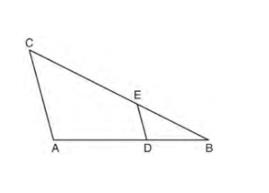

Given: In the diagram, DE is parallel to AC, BD=4, DA=6, and EC=8. Find BC to the nearest tenth.

