Name____________________________________ Parallel/ Perp Station 1
- What is the slope of a line perpendicular to the line whose equation is -4y = −6x + 8?

- Write an equation parallel to the line whose equation is 6y − 2x = 10?

- Are the two lines perpendicular, parallel, or neither? 2y = 4x + 4 and y + 2x = -4

- Write the equation of a line parallel to the line y = 3

- Write the equation of a line perpendicular to the line y = x

- Write the equation of a line perpendicular to the line x = -4

Name__________________________________ Parallel/Perp Equation Station 2
- What is the equation of a line parallel to the line -4y = 1x + 8 and through the point (3, -5)

- What is the equation of a line perpendicular to the line -2y + 5 = 8x – 2 and through the point (8, -2)

- What is the equation of a line parallel to the line x = -2 and through the point (3, -5)

- What is the equation of a line perpendicular to the line y = 4 and through the point (-8, 9)

Name______________________________________ Graphing Station 3
Graph the following equation:
- y = x 4. 3y – 6 = 2x
- x = 3
3. y = 2
5. 8y + 2x = 4
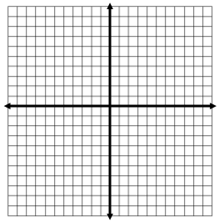

Name____________________________________________ Systems of Equations Station 4
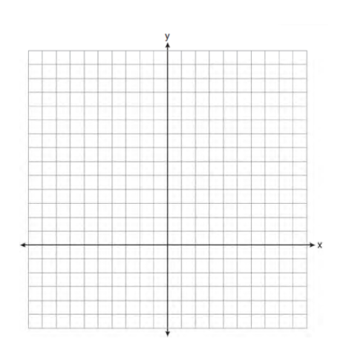
On the set of axes, solve the following system of equations graphically for all values of x and y
$${y=\left(x-2\right)}^{2}+4$$
$$4x+2y=14$$

