Equation of a Perpendicular Bisector
Perpendicular:
Bisector:
Steps:

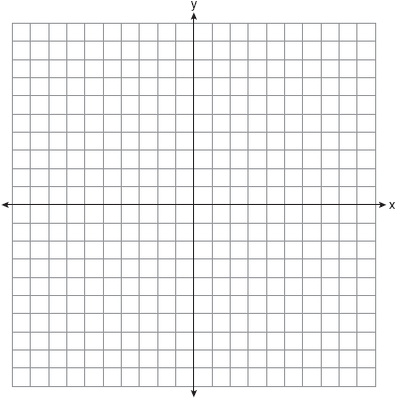
Examples: Write the equation of a line that is a Perpendicular Bisector to the line segment with the following endpoints : A ( 1,3 ) and B (5, -3 )

Practice:
1. Write the equation of a line that is a Perpendicular Bisector to the line segment with the following endpoints : A ( 7,5 ) and B (1, -3 )

2. Write the equation of a line that is a Perpendicular Bisector to the line segment with the following endpoints : A (3,4 ) and B (-1, 0)

3. Write the equation of a line that is a Perpendicular Bisector to the line segment with the following endpoints : A (-4,-1 ) and B (2,-7 )

4. Write the equation of a line that is a Perpendicular Bisector to the line segment with the following endpoints : A (-4, 3 ) and B (- 2,9 )

