Name____________________________________ Desmond - Period 9
Directions: SHOW ALL WORK-NO WORK, NO CREDIT! Work independently; Mrs. Lewis will give you a zero if you work with others on this assignment.
- Find the measure of ∠AOB in each of the following diagrams.
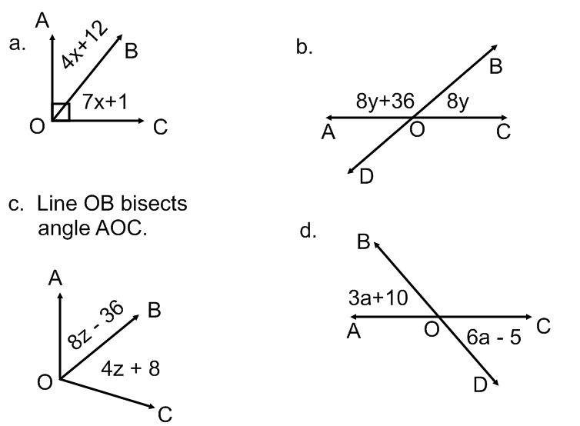

- Two supplementary angles are in the ratio of 7:5. Find the value of the larger angle.

- Which of the following sets of side lengths could represent a right triangle? (Circle all that apply).

- {14,28,50} b. {8,17,21} c. {9,12,15} d. {7, 15, 17}

- What is the length of the line between the points (2,-4) and (13, 12)?
- $\sqrt{185}$ b. $\sqrt{377}$ c. $17$ d. $\sqrt{481}$

- What is the center and radius of a circle whose equation is ${(x-12)}^{2}+{ (y+5)}^{2}=9$ ?

- (12,-5) and 9 b. (12, -5) and 3 c. (-12,5) and 9 d. (-12,5) and 3

- What is the equation of the circle below?
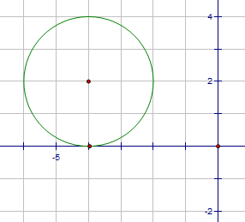
a. ${(x-4)}^{2}+{(y+2)}^{2}=2$
b. ${(x-4)}^{2}+{(y+2)}^{2}=4$
c. ${(x+4)}^{2}+{(y-2)}^{2}=2$
d. ${(x+4)}^{2}+{( (y-2)}^{2}=4$

- Find the midpoint of the line AB when A(2a+4, 3b-2) and B(4a+4, b-6).
- (3a+4, 2b-4) b. (6a+8, 4b-8) c. ( 2a, -2b – 4) d. (a, -b-2)

- What is the slope of a line perpendicular to the line whose equation is -4y = −8x + 8?
- $\frac{1}{2}$ b. $-\frac{1}{2}$ c. $2$ d. $-2$

- If A(2,5) is an endpoint of line AB and M(6, 1) is the midpoint, find the coordinates of B, the other endpoint.
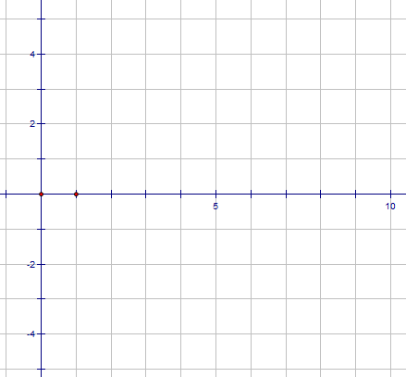
a. (4, 3)
b. $(10, -3)$
c. $(-2, 9)$
d. $(2, -2)$

- The two lines 2y = 4x + 4 and y + 2x = -4 are
- Perpendicular b. parallel c. neither d. the same line.

- What is the equation of a line parallel to the line -4y = 1x + 8 and through the point (8, -5)

- $y=4x-37$ b. $y= -4x+27$ c. $y= -\frac{1}{4}x+7$ d. $y= \frac{1}{4}x-3$

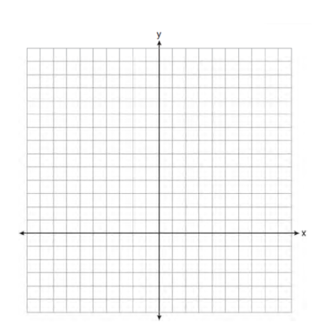
12. On the set of axes, solve the following system of equations graphically for all values of x and y
$${y=\left(x-2\right)}^{2}+4$$
$$4x+2y=14$$

13. In the diagram of shown below, is drawn from vertex B to point A on , such that .

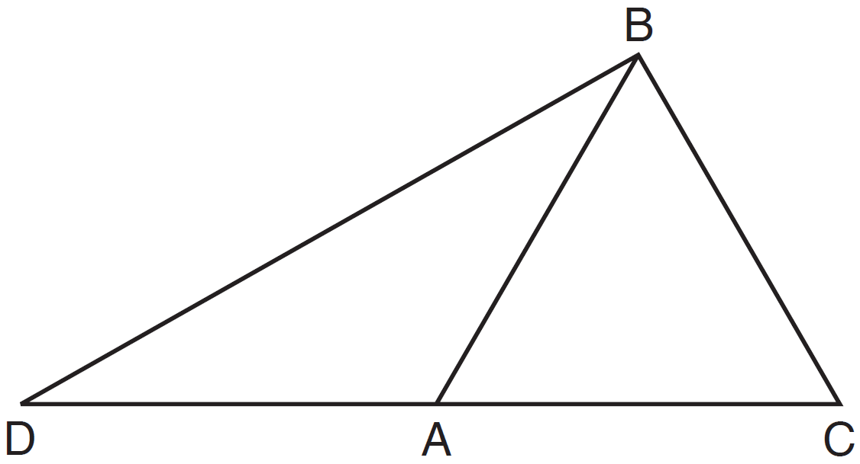

In , , , and . In , and . [Only algebraic solutions can receive full credit.]
- Find .

- Find .

- Find the length of .

- Find the length of .

