Notes - Triangle exterior angle theorem:

In your groups, find the value of the exterior angle of these 3 triangles?
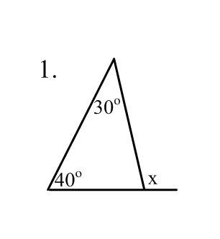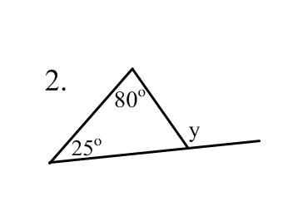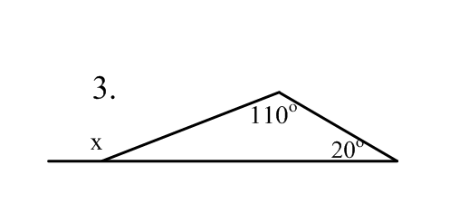
With your partners, write a conclusion that relates the two interior angles of a triangle to the third
angle's exterior angle.
_________________________________________________________________________________
Exterior Angle Theorem:

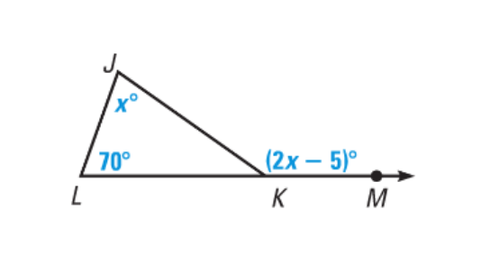
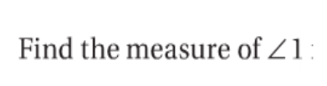
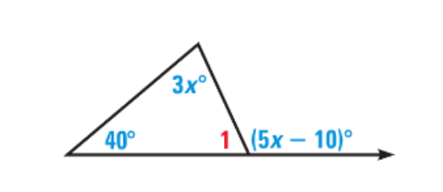
Describe and correct the error.
