Vocabulary Definition Picture
Point
Line

Plane

Collinear Points

Coplanar Points

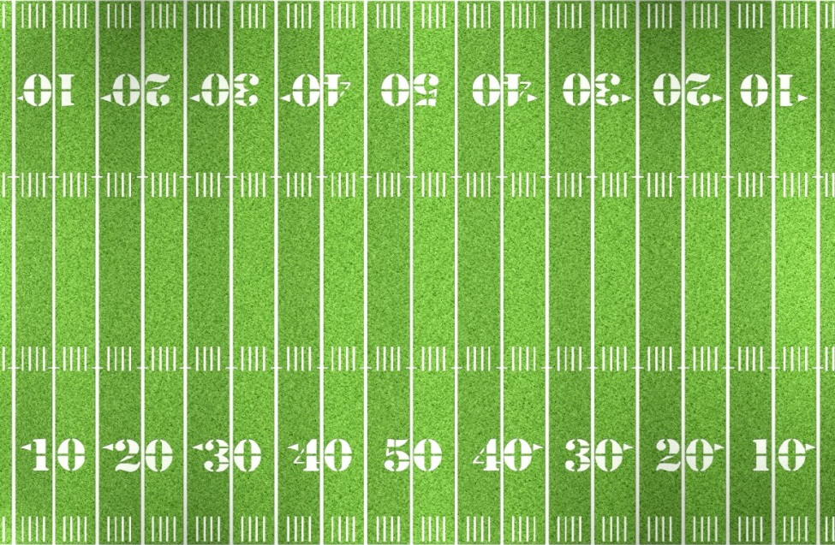
2
1
C
B
A
3
Name three points that are collinear ____________________
Name 4 points that are coplanar _______________________

Intersections
The intersection of two lines is a _________________________
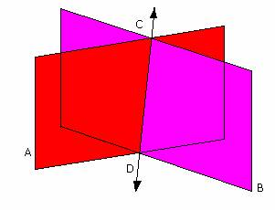 The intersection of two different planes is a_________________________
PRACTICE!
Draw the following:
Intersecting lines on one plane

Lines j and k intersect at point P. Line m is drawn so that it is perpendicular to lines j and k at point P.

Point P is on line m. Draw a plane perpendicular to line m that passes through point P

