Unit 7
Triangle and Quadrilateral Proofs
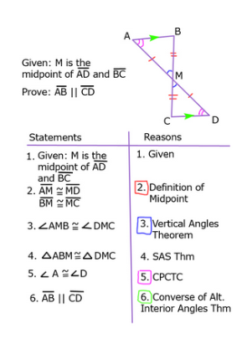
Geometry – Desmond
Triangle Proofs
5 Triangle Proofs
1.

2.

3.

4.

5.

NEVER USE

CPCTC

Types of segments
Altitude

Angle Bisector

Median

VERTICAL ANGLES
- Given: AC = XZ, <AEC = XEZ, <ACE = <XZE. Prove ACE$\tilde{=}$ XZE
A
X
E
Z
C

- Given: AE = XE and ZE = CE. Prove ACE$\tilde{=}$ XZE
A
X
E
Z
C

- Given AE = XE and BE = ZE. Prove ABE$\tilde{=}$ XZE

Z
X
E
B
A

REFLEXIVE PROPERTY
- Given: AC = BC, AE = BE, EC = EC. Prove AEC$\tilde{=}$ BEC
EE
C

A
B

- Given: m<AEC = m<EAC and m<BEA=m<CAE. Prove AEC$\tilde{=}$ BEC
B
EE

C
A

- Given: m<AEB = m<FBE, m<ABE=m<FEB. Prove ABE $\tilde{=}$ FBE
EE
A

B
FE

PARALLEL LINES
Statements Reasons__________________
Given: $∠1≅∠3$
$\overline{QU} || \overline{DA}$
Prove: QUA $\tilde{=}$ ADQ

Given:$C is the midpoint of \overline{AE} and \overline{AB} || \overline{DE}$
Statements Reasons__________________
Prove: ACB $\tilde{=}$ ECD
D
A

E
C
B

Statements Reasons__________________
Given: Parallelogram QDAU
Prove: QAD $\tilde{=}$ ADQ

CPCTC

Ex. 1  $ΔQRS=ΔXYZ$  $$∠Y= _____$$  $\overline{QS}= _____$  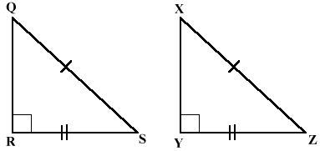 | Ex. 2  $$ΔABC=ΔDEF$$  $$∠A= _____$$  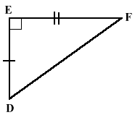  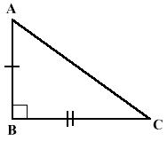  $\overline{FE}= _____$ | Ex. 3  $$ΔGHI=ΔJKL$$  $$\overline{GI}= _____$$  $$∠J= _____$$  Draw your own!

1 Given .
Which statement must be true?
1)
2)
3)
4)
2. If , which statement is
always true?
1)
2)
3)
4)

YOU MUST ALWAYS PROVE THE TRIANGLES ARE CONGRUENT FIRST!!
Statements Reasons__________________

Given: Triangle ACB is an isosceles triangle and CE bisects AB
Prove: $∠AEC≅∠BEC$
EE
C

A
B

Statements Reasons__________________
