Isosceles Triangles have two sides congruent and two angles congruent.

**Isosceles Triangle**

A

B

A

B

A

C

C

C

B

AC = AB BC = AB $∠$ A = $∠$ B

1. Given triangle ABC with $∠$ A = 62 and $∠B$ = 56 prove that triangle ABC is an isosceles triangle.

2. In isosceles triangle ABC, AB = BC. Which statement will always be true?

1) mB = mA 2) mA > mB 3) mA = mC 4) mC < mB

3. In the diagram ΔABC below, $\overline{AB}=\overline{AC}.$ The measure of A?

1) 40° 2) 50° 3) 70° 4) 100°

4. In ΔRST, mRST = 46° and . Find mSTR.

5. If LM = LO, what kind of triangle is triangle MNO?



6. Hersch says if a triangle is an obtuse triangle, then it cannot also be an isosceles triangle. Using a diagram, show that Hersch is incorrect, and indicate the measures of all the angles and sides to justify your answer.

7. The accompanying diagram shows the roof of a house that is in the shape of an isosceles triangle. The vertex angle formed at the peak of the roof is 84°.

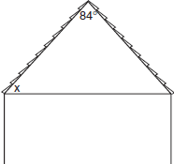

What is the measure of *x*?

1) 138° 2) 96° 3) 84° 4) 48°

8. Tina wants to sew a piece of fabric into a scarf in the shape of an isosceles triangle, as shown in the accompanying diagram.

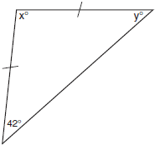

What are the values of *x* and *y*?

1)  2)  3)  4) 

EXTRA CREDIT – CHALLENGE PROBLEMS

1. In the accompanying diagram, isosceles , , and . Find and .

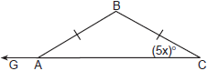 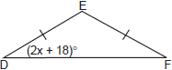

2. In isosceles triangle *DOG*, the measure of the vertex angle is three times the measure of one of the base angles. Which statement about is true?

1) is a scalene triangle. 2) is an acute triangle.   
 3) is a right triangle. 4) is a obtuse triangle.

1. In the accompanying diagram, and are isosceles triangles with  and . If and , what is ?

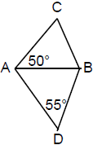

1. Vertex angle *A* of isosceles triangle *ABC* measures 20° more than three times . Find .