Exterior Angles – Polygons
Sum of exterior angles of ANY polygon =_________
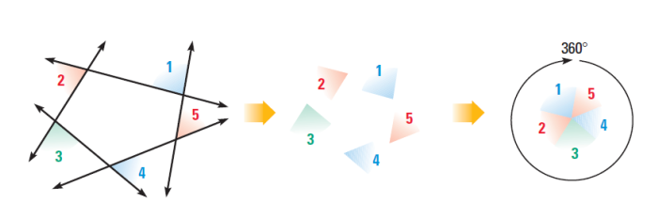
- How many degrees are there in the sum of the exterior angles of a dodecagon?

- Find the number of degrees in each exterior angle of a regular pentagon

- If each exterior angle of a regular polygon contains 40$°,$how many sides does the polygon have?

- What is the measure of one exterior angle of a regular decagon?

- What is the sum of the exterior angles of a polygon with 36 sides?

- What is the measure of each exterior angle of a stop sign?
Argument Writing
Remember the steps: 1. State your claim
2. Show your math work
3. Reasoning
4. Counter Claim
Are these two lines parallel when x = 50 (use proper vocabulary!!)
3x + 4
155

_____________________________________________________________________________________________________________________________________________________________________________________________________________________________________________________________________________________________________________________________________________________________________________________________________________________________________________________________________________________
- What is the sum, in degrees, of the measures of the interior angles of a stop sign, which is in the shape of an octagon?
(1) 360$°$ (3) 1,440$°$
(2) 1,080$°$ (4) 1,880$°$

- What is the sum, in degrees, of the measures of the interior angles of a pentagon?
(1) 180$°$ (3) 540$°$
(2) 360$°$ (4) 900$°$

- The measures of five of the interior angles of a hexagon are 150$°$, 100$°$, 80$°$, 165$°$, and 150$°$. What is the measure of the sixth interior angle?
(1) 75$°$ (3) 105$°$
(2) 80$°$ (4) 180$°$

- The accompanying figure represents a section of bathroom floor tiles shaped like regular hexagons
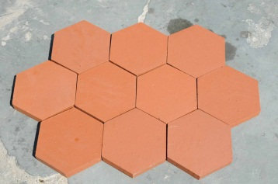
C
What is the measure of <ABC?
(1) 60$°$ (3) 120$°$
(2) 90$°$ (4) 150$°$
B
A
- What is the measure, in degrees, of each exterior angle of a regular hexagon?
(1) 45$°$ (3) 120$°$
(2) 60$°$ (4) 135$°$

- A stop sign in the shape of a regular octagon is resting on a brick wall, as shown in the accompanying diagram.
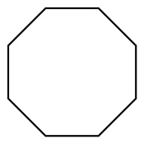
What is the measure of angle x?
(1) 45$°$ (3) 120$°$
(2) 60$°$ (4) 135$°$

STOP
x

- One piece of a birdhouse that Natalie is building is shaped like a regular pentagon, as shown in the accompanying diagram.
If side AE is extended to point F, what is measure of exterior angle DEF?
(1) 36$°$ (3) 108$°$
(2) 72$°$ (4) 144$°$

F
E
B
D
C
A

- Melissa is walking around the outside of a building that is in the shape of a regular polygon. She determines that the measure of one exterior angle of the building is 60$°$. How many sides does the building have?
(1) 6 (3) 3
(2) 9 (4) 12

