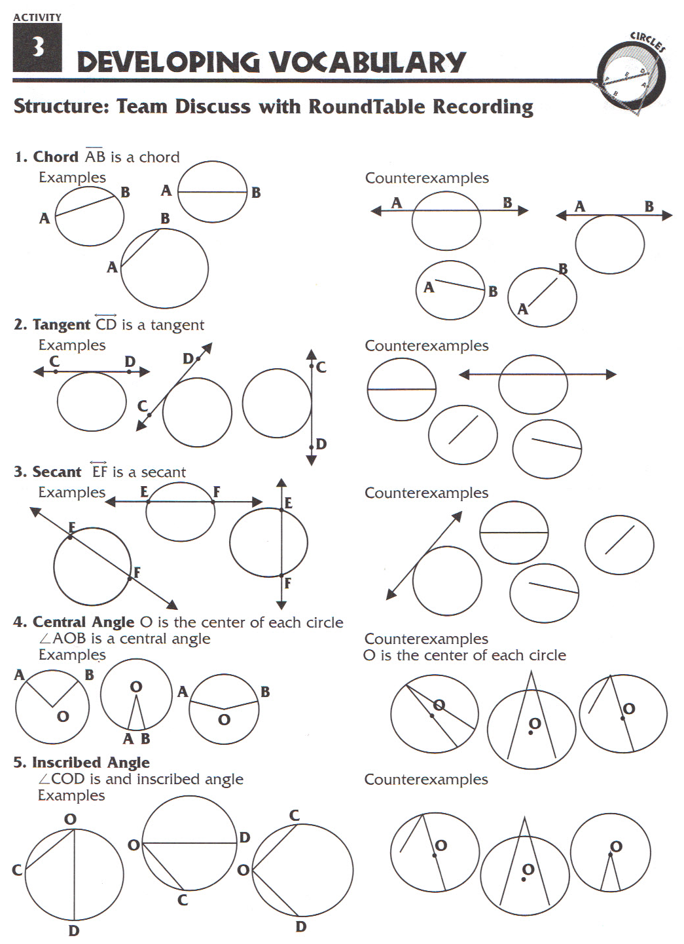
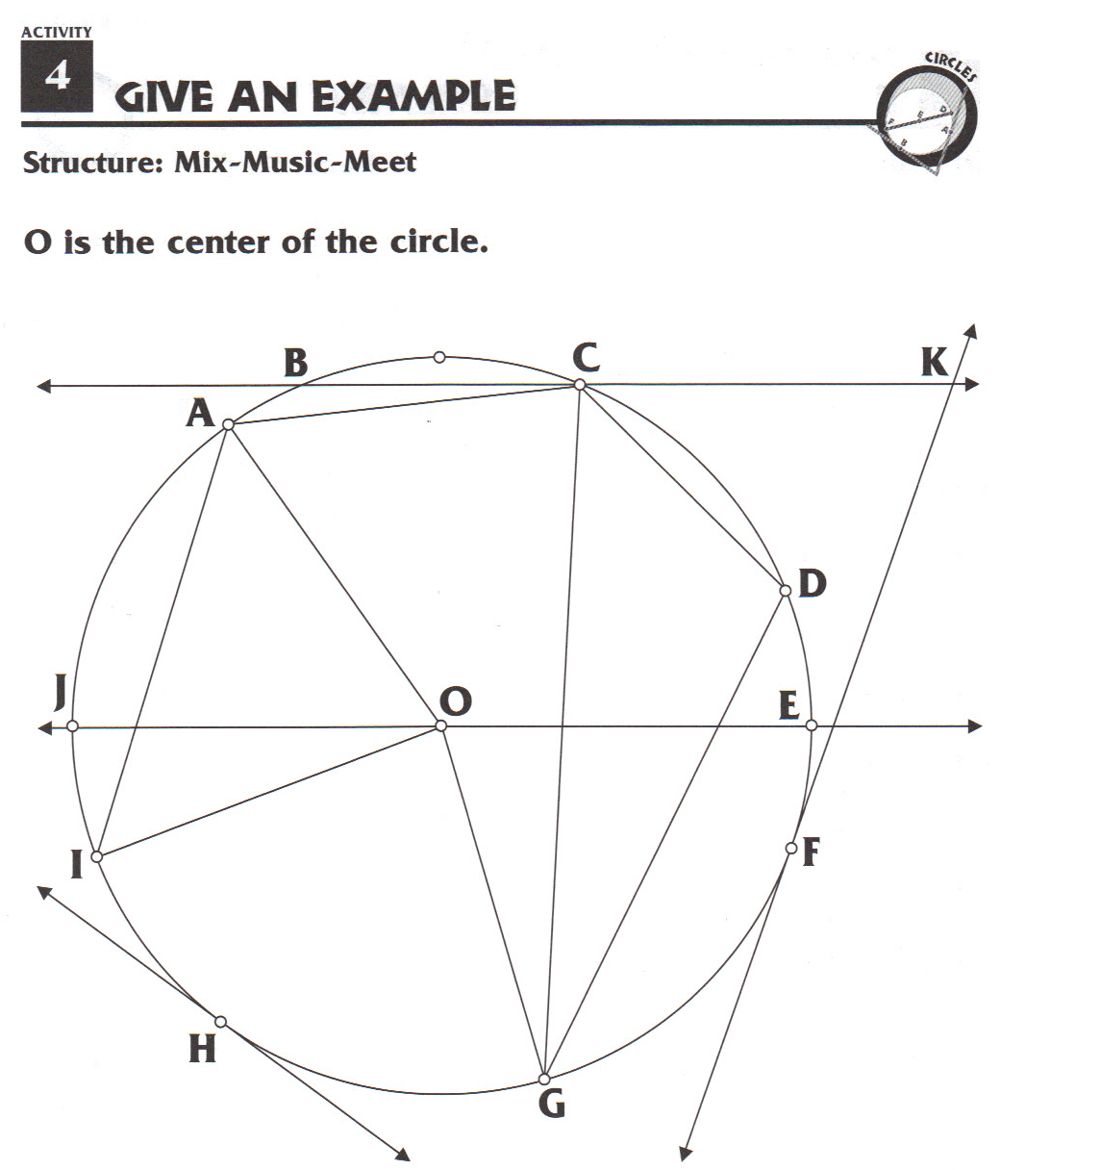
Circle Theorems

Picture | Mathematical Rule | In Words | Example
Central Angle

Inscribed Angle

Right Triangle Theorem

Tangents from the
Same Point

Exterior Angles

Interior Angles
formed by Chords

Measures of Chords

Measures of Exterior Line Segments

Circle Geometry Vocabulary

A CIRCLE is a set of points that are equidistant from a fixed point called the center. The perimeter (outside) of the circle is called the circumference.

Radius | A radius is the line segment from the center to any point on the circumference (outside).
Central Angle | An angle that has its vertex at the center of the circle. It’s sides are radii.
Chord | A line segment that connects two points on the circumference of the circle.
Diameter | A chord that passes through the center of the circle.
Inscribed Angle | An angle that has its vertex on the circumference of the circle and it’s sides are chords.
Tangent | A line that intersects the circle at exactly one and only one point.
Secant | A line that intersects the circle in two points.

Example:
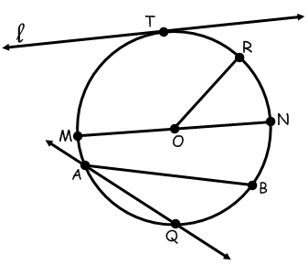

In the accompanying diagram, name all:

Radii: __________________________________________________________

Central Angles: __________________________________________________________

Chords: __________________________________________________________

Diameters: __________________________________________________________

Inscribed Angles: __________________________________________________________

Tangents: __________________________________________________________

Secants: __________________________________________________________

Arc | Any portion of the circumference between two points.
Semi-Circle | Measures exactly half of the circumference. Equals 180º.
Minor Arc | An arc with a measure that is less than 180º. Less than a semi-circle.
Major Arc | An arc with a measure that is more than 180º. More than a semi-circle.


Example: In the accompanying diagram, name all:

Semi-circle: _____________________________________________________________

Minor Arcs: _____________________________________________________________

Major Arcs: _____________________________________________________________

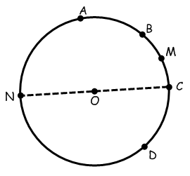

Geometry of a Circle

1) Basic Rules:


2) Arc Addition & Subtraction (by Extension):
If AB and BC are arcs of the same circle having a common endpoint and no other points in common, then mAB + mBC = mAC.

3) Central Angles
A degree measure of an arc is equal to the measure of the central angle that intercepts it.

Example 1:
In Circle O, mAOB = 87º, mBOC = 93º, mCOD = 35º. Find the measure of each of the following:
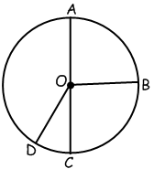
a. mDOA =
b. m AB =
c. m BC =
d. m ABC =
e. m DC =
f. m AD =
g. m BCD =
h. m CDB =
i. m DBC =
Example 2: In circle O, AOB is a straight angle and mBOC = 15º, find:

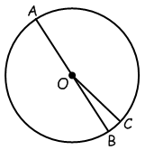
a. mAOC =
b. m AC =
c. m BC =
d. m AB =
e. m ABC =

Practice Questions:


