Name__________________________________ Unit Test 1 Review

Part I (MUST SHOW ALL WORK FOR CREDIT!!!)
1) What is the slope of a line perpendicular to the line whose equation is 3y = −2x + 9?

2) Which equation represents a line parallel to the line whose equation is 5y − 10x = 10?
a) 4y – 8x = 10 b) 5y + 10x = 10 c) 4y + 8x = 12 d) 10y + 5x = 8

3) What is an equation of the line that contains the point (-2,5) and is perpendicular to the line whose equation is y = −4x + 4?

4) What is an equation of the line that passes through the point (3,-2) and is parallel to the line
3x + 4y = 12?

5) What is an equation for the circle shown in the graph below?
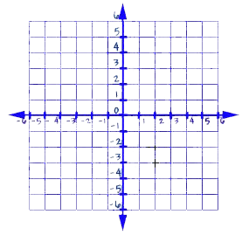
6) A circle has the equation (x + 3)² + (y - 2)² = 25. What are the coordinates of its center and
the length of its radius?

7) The endpoints of CD are C(8,-4) and D(3,-2). What are the coordinates of the midpoint of CD?

8) What is the length of the line segment whose endpoints are A(-11,9) and B(8,2)?

Part II (Short Answer – SHOW ALL WORK)

9) In the diagram below of circle C, QR is a diameter and Q(5,-8) and C(5.5,-3) are points on a coordinate plane. Find and state the coordinates of point R.

10) Write the equation of the circle with diameter 4 and center (-8, 2).

11) Write the equation of the circle given a diameter with endpoints (2,6) and (-4,-8)

12) Write an equation of the perpendicular bisector of the line segment whose endpoints are (−1, 1) and (7, −5).

13) Put the following in simplest radical form $\sqrt{108}$

14) Solve the following system of equations graphically

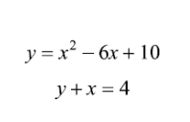
b) (x − 3)² + (y + 2)² = 16
x = 3
