Locus ________________________________________________________________________________

Equidistant____________________________________________________________________________

Draw locus for each of the five below

Find the points three units away from line l. Find the points 5 units away from point A

A

l

Find the points equidistant from lines x and y Find the points equidistant from points r and k

x

y

r

k

Find the points two units away from x = 2 Find the points 3 units away from (4, -1)

[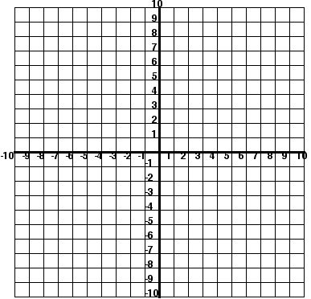](http://www.pleacher.com/mp/mlessons/algebra/graph.html) [](http://www.pleacher.com/mp/mlessons/algebra/graph.html)

Find the points equidistant from y = 2 and y = -4 Find the points equidistant from (1,3) and (3,1)

[](http://www.pleacher.com/mp/mlessons/algebra/graph.html) [](http://www.pleacher.com/mp/mlessons/algebra/graph.html)

Find the points 4 units from the origin Find the points equidistant from the   
 y axis and x axis

[](http://www.pleacher.com/mp/mlessons/algebra/graph.html) [](http://www.pleacher.com/mp/mlessons/algebra/graph.html)

Let’s put them together! Find the points equidistant from y = 1 and y = 5 and 4 units from the point (3,1). Label with an x the points that satisfy both conditions

Steps to finding compound loci

Step 1

Step 2

Step 3

Step 4

[](http://www.pleacher.com/mp/mlessons/algebra/graph.html)

On the set of axes below, graph the locus of points that are 4 units from the line x = 3 and the locus of points that are 5 units from the point (0,2). Label with an **X** all points that satisfy both conditions.

[](http://www.pleacher.com/mp/mlessons/algebra/graph.html)

On the set of axes below, graph the locus of points equidistant from the points (4,1) and (-1,1) and two units from the origin.

[](http://www.pleacher.com/mp/mlessons/algebra/graph.html)

Math Criminal! – “The money is equidistant from Westcott St. and Allen St. and   
 one unit away from Alto Cinco.”

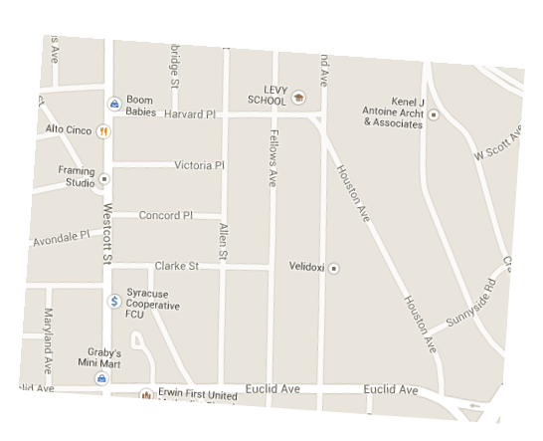

In a park, two straight paths intersect. The city wants to install lampposts that are both equidistant from each path and also 15 feet from the intersection of the paths. How many lampposts are needed?

Towns *A* and *B* are 16 miles apart. How many points are 10 miles from town *A* and 12 miles from town *B*?

In the diagram below, car A is parked 7 miles from car B. Sketch the points that are 4 miles from car A and

sketch the points that are 4 miles from car B. Label with an X all points that satisfy both conditions.



Given line l with point p on line l. Find all the points 3 units from line l and 4 units from point p.

Create your own: _______________________________________________________________________________  
  
______________________________________________________________________________________________

______________________________________________________________________________________________

______________________________________________________________________________________________

______________________________________________________________________________________________

(Have someone else solve!)